

**SWP391 PROJECT REPORT**

**Software Design Specification**

– Da Nang, July 2023 –

Table of Contents

Contents

I. Record of Changes 1

II. Software Design Document 2

1. Overall Description 2

1.1. Assumptions 2

1.2. Design Constraints 2

2. System Design 2

2.1 System Architecture 2

2.2 Package Diagram 4

3. Database Design 5

3.1 Database diagram 5

3.2 Schema Descriptions 6

4. Detailed Design 7

4.1 Register Sequence Diagram 8

4.2 Sign in Sequence Diagram 9

4.3 Change Password Sequence Diagram 10

4.4 Sign Out Sequence Diagram 11

4.5 View Landing Page Sequence Diagram 11

4.6 Manage Profile Sequence Diagram 12

4.7 View All Room Sequence Diagram 13

4.8 Search Room Sequence Diagram 14

4.9 Register Room Sequence Diagram 14

4.10 Room Registration History Sequence Diagram 16

4.12. Load Room Payment Sequence Diagram 17

4.13. Load Electric And Water Payment Sequence Diagram 18

4.14 Room, Electric And Water Payment Sequence Diagram 19

4.15 Request To Change Room Sequence Diagram 20

4.16 Send Maintenance, Complain Sequence Diagram 21

4.17 View All Notifications Sequence Diagram 22

4.18 Create A Notification Sequence Diagram 23

4.19 Update Notifications Sequence Diagram 24

4.20 Delete Notifications Sequence Diagram 25

4.21 View All Student Information Sequence Diagram 26

4.22 View All Room By Manager Sequence Diagram 27

4.23 Create A Room Sequence Diagram 27

4.24 Update A Room Sequence Diagram 28

4.25 Delete A Room Sequence Diagram 28

4.26 View All Electric And Water Bill Sequence Diagram 29

4.27 Create An Electric And Water Bill Sequence Diagram 30

4.28 Update Electric And Water Bill Sequence Diagram 30

4.29 Delete Electric And Water Bill Sequence Diagram 31

4.30 View statistic Sequence Diagram 31

Table of Figures

Figure 1. System Architecture Diagram 2

Figure 2. Dormitory System-client Package Diagram 4

Figure 3. Dormitory System-web-app Package Diagram 5

Figure 4. FDorm’s platform database diagram 6

Figure 5. Register Sequence Diagram 15

Figure 6. Login Sequence Diagram 16

Figure 7. Register Sequence Diagram 17

Figure 8. Forgot Password Sequence Diagram 18

Figure 9. Sign Out Sequence Diagram 19

Figure 10. Change Password Sequence Diagram 19

Figure 11. Search Course, Mock Test, Question, Blog Sequence Diagram 20

Figure 12. Enrol a Course Sequence Diagram 21

Figure 13. Like Course, Mock Test, Blog, Question, Chapter, Comment Sequence Diagram 22

Figure 14. Do Mock Test/ Question Sequence Diagram 22

Figure 15. Retake Mock Test/ Question Sequence Diagram 23

Figure 16. Deposit Coin Sequence Diagram 24

Figure 17. Withdraw Coin Sequence Diagram 25

Figure 18. Buy Course, Mock Test, Video, Question Sequence Diagram 26

Figure 19. Become Knowledge Sharer/Upgrade Account Sequence Diagram 27

Figure 20. View Notification, Courses, Mock Test,… Sequence Diagram 28

Figure 21. Create Notification, Courses, Mock Test,… Sequence Diagram 29

Figure 22. Update Course, Blogs, Mock Tests, … Sequence Diagram 30

Figure 23. Delete Course, Blogs, Mock Tests Sequence Diagram 31

Figure 24. Accept/ Reject Course, Blogs, Mock Tests Sequence Diagram 32

Figure 25. Upload Image/Video Sequence Diagram 33

Figure 26. Send Notification Sequence Diagram 34

Table of Tables

Table 1. Package Descriptions 4

Table 2. Schema Descriptions 7

Table 3. Schema User 9

Table 4. Schema Course 10

Table 5. Schema Chapter 10

Table 6. Schema Video 11

Table 7. Schema Mock Test 11

Table 8. Schema Question 12

Table 9. Schema Blog 13

Table 10. Schema Comment 13

Table 11. Schema Transaction 14

Table 12. Schema Notification 14

Table 13. Schema Activity Logs 15

# Record of Changes

|  |  |  |  |
| --- | --- | --- | --- |
| **Date** | **A*, M, D** | **In charge** | **Change Description** |
| 09/06/2023 | A | All | Add initial version |

*A - Added M - Modified D - Deleted

# Software Design Document

## Overall Description

### Assumptions

* + - * Operating System: The Dormitory system will be running on Windows Operating system.
      * Hardware: The Dormitory system will be running on at least 1 core processor, 1GB RAM, and 20GB disk space.
      * Network Connectivity: The Dormitory system assumes that an internet connection is available for communication with external services or databases.
      * Network Connectivity: The Dormitory system assumes that an internet connection is available for communication with external services or databases.
      * Third-party libraries: The Dormitory system assumes the availability and compatibility of third- party libraries or APIs that Dormitory system relies on are quite good.

### Design Constraints

* + - * Websites must be designed to handle high traffic, as multiple users can access the site at the same time.
      * The website must be accessible on different devices, including desktops, laptops, tablets, and smartphones.
      * The website must be designed with security in mind, to protect user data and prevent unauthorized access to the website.
      * Websites should be designed to load quickly, ensure a smooth user experience, and minimize frustration.
      * The website must be designed to be extensible, so that it can accommodate future growth and expansion.

## System Design

### System Architecture

##### System Architecture Diagram

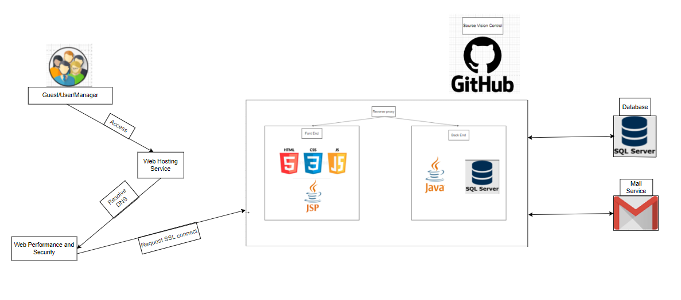

**Figure 1. System Architecture Diagram**

##### System Architecture Explanation

#### HTML

The different elements and tags used by HTML to define a webpage's headings, paragraphs, links, pictures, tables, and forms. These tags give browsers guidance on how to format and display the information.

#### CSS

CSS gives site designers control over a webpage's visual elements, including its layout, colors, fonts, and other elements. CSS gives users more freedom and control over how web pages look by separating display from document structure and content..

#### JS

Form validation, DOM manipulation (changing the content and structure of a webpage), event handling (responding to user actions like clicks and keystrokes), making asynchronous server requests (AJAX), and creating animations and effects are just a few of the many tasks that can be carried out using JavaScript.

#### JSP

In-built Java support, access to Java objects and libraries, session management, and integration with Java servlets and other Java EE technologies are just a few of the advantages offered by JSP. It makes it possible to create dynamic web pages that can communicate with databases, handle user input, and produce information that is tailored to the individual.

#### Java-Java Servlet

The request-response model is how servlets operate. A client sends a request to the server, which the servlet then processes and provides back to the client. Servlets can operate with many data formats including HTML, XML, JSON, and others and can handle a variety of request types like GET, POST, PUT, and DELETE.

#### SQL server

SQL Server manages and processes data using the Structured Query Language (SQL). It offers strong features for data storage, retrieval, and manipulation while supporting a wide range of data types. Through compliance with ACID (Atomicity, Consistency, Isolation, Durability), SQL Server offers transactional integrity, data consistency, and reliability.

### Package Diagram

##### Package Descriptions

|  |  |  |
| --- | --- | --- |
| **No** | **Package** | **Description** |
| 01 | Dormitory System -client | All package for Dormitory System-client project |
| 02 | Dormitory System -web-app | All package for Dormitory System -web-app project |

**Table 1. Package Descriptions**

##### Package Diagram

1. **Dormitory System-front end**

Below is the directory organization of the Dormitory System project's front-end consists of a structured arrangement of files and folders that organize and manage the project's user interface components. This organization allows for efficient management and easy navigation within the project.

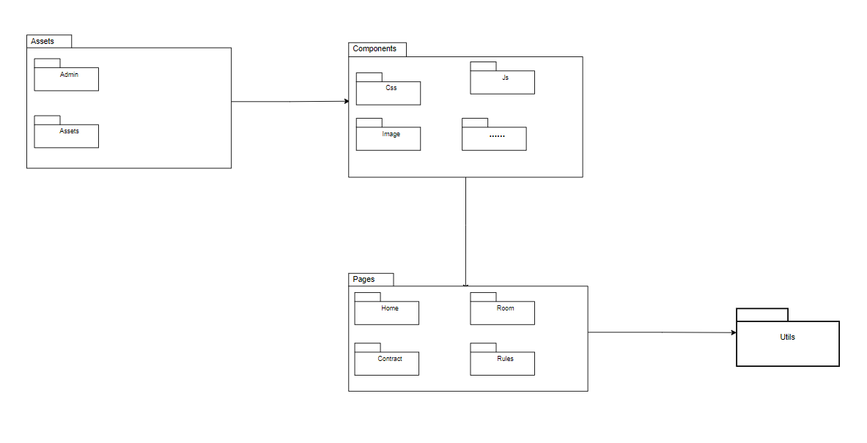

**Figure 2. Dormitory System-client Package Diagram**

1. **Dormitory System-back end**

Below is the directory organization of the Dormitory System project's back-end is a structured system of files and folders that organize and manage the project's server-side components. This organization facilitates efficient management and easy navigation within the project, ensuring that developers can quickly find and modify the necessary files.

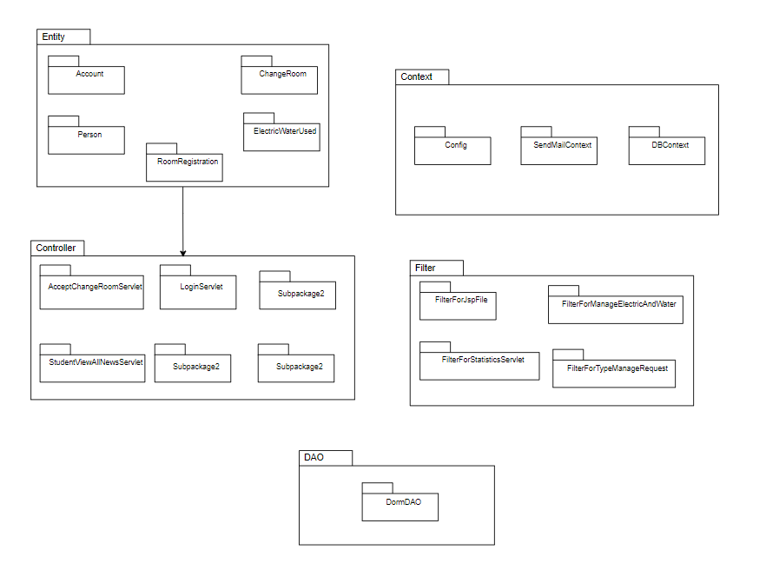

**Figure 3. Dormitory System-web-app Package Diagram**

## Database Design

### Database diagram

Our project's database is a comprehensive system designed to store and manage all the data related to our project. It consists of 8 tables that hold different types of information such as: person, account, RegisterRoom, ... We use SQL server in this project, below is the database schema we describe:

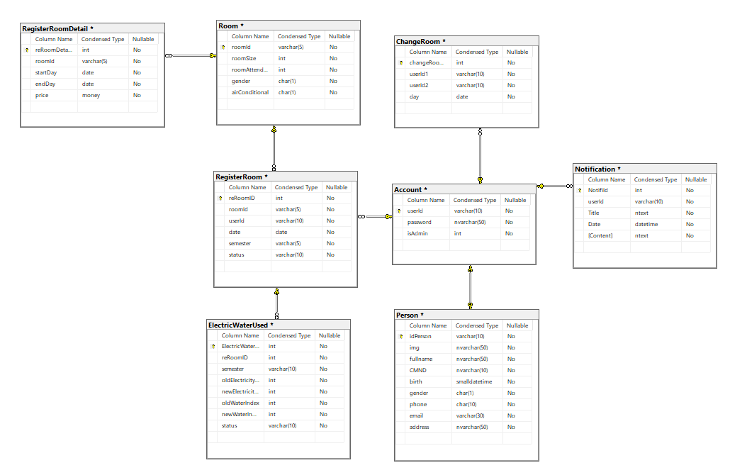

**Figure 4. FDorm’s platform database diagram**

### Schema Descriptions

|  |  |  |
| --- | --- | --- |
| **No** | **Schema** | **Description** |
| 01 | Account | This schema stores all information of User, Admin which contains fields such as userID, password. |
| 02 | Person | This schema stores user and admin information which contains fields such asid, image, full name, and other related information. |
| 03 | RegisterRoom | This schema stores information about room booking including: room registrant id, roomId, registration date, … |
| 04 | Room | This schema stores information about the requirements of the registered room |

|  |  |  |
| --- | --- | --- |
| 05 | RegisterRoomDetail | This schema stores information about room booking details including registration date, price, etc. |
| 06 | ChangeRoom | This schema stores information about the information of room change requester and room changer. |
| 07 | Notification | This schema stores information about dormitory messages to students. |
| 08 | ElectricWaterUsed | This schema stores information about electricity and water usage. |

**Table 2. Schema Descriptions**

## Detailed Design

### Register Sequence Diagram

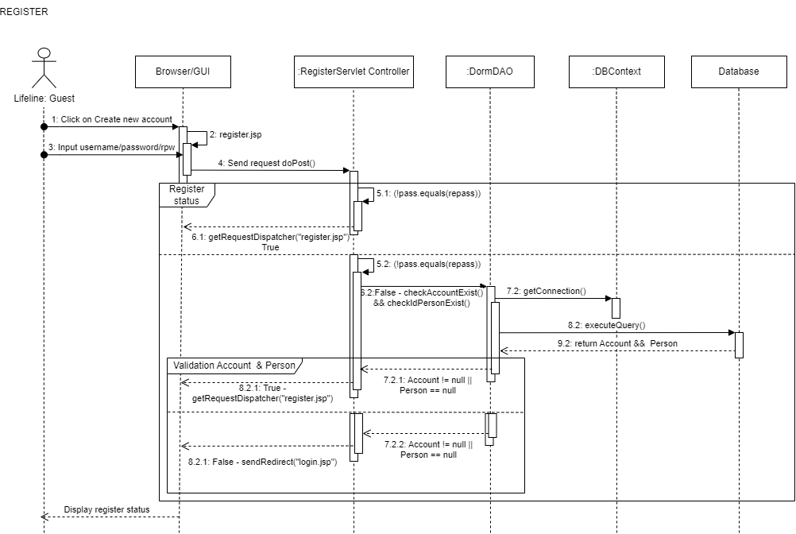

**Figure 5. Register Sequence Diagram**

### Sign in Sequence Diagram

**Figure 6. Sign in Sequence Diagram**

### Change Password Sequence Diagram

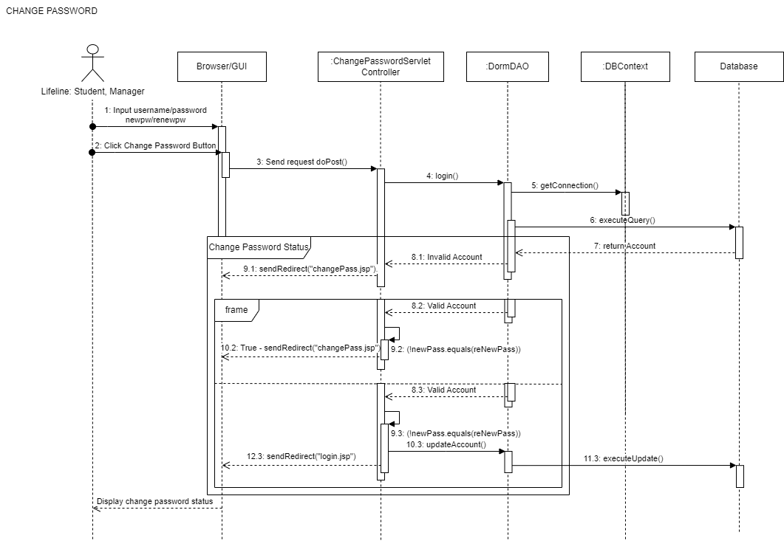

**Figure 7. Change Password Sequence Diagram**

### Sign Out Sequence Diagram

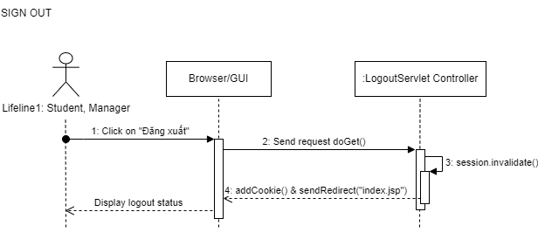

**Figure 9. Sign Out Sequence Diagram**

### View Landing Page Sequence Diagram

### 

**Figure 10. View Landing Page Sequence Diagram**

### Manage Profile Sequence Diagram

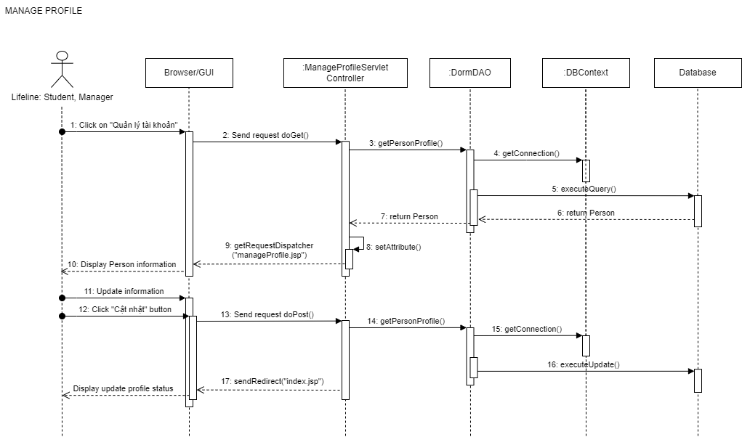

**Figure 11. Manage Profile Sequence Diagram**

### View All Room Sequence Diagram

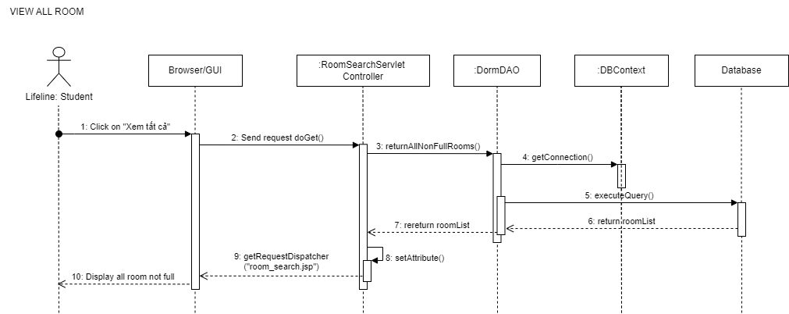

**Figure 12. View All Room Sequence Diagram**

### Search Room Sequence Diagram

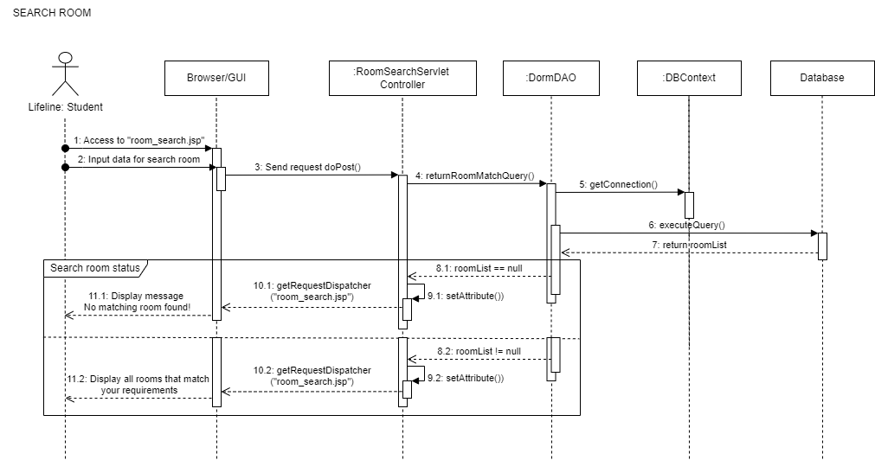

**Figure 13. Search Room Sequence Diagram**

### Register Room Sequence Diagram

### 

**Figure 14. Register Room Sequence Diagram**

### Room Registration History Sequence Diagram

### 

**Figure 15. Room Registration Sequence Diagram**

### Load Room Payment Sequence Diagram

**Figure 16. Load Room Payment Sequence Diagram**

### Load Electric And Water Payment Sequence Diagram

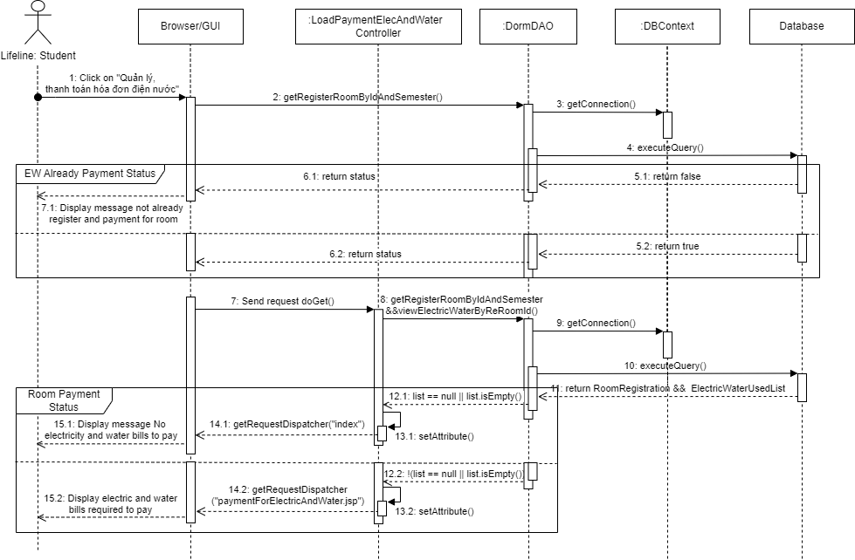

**Figure 17. Load Electric And Water Payment Sequence Diagram**

### Room, Electric And Water Payment Sequence Diagram

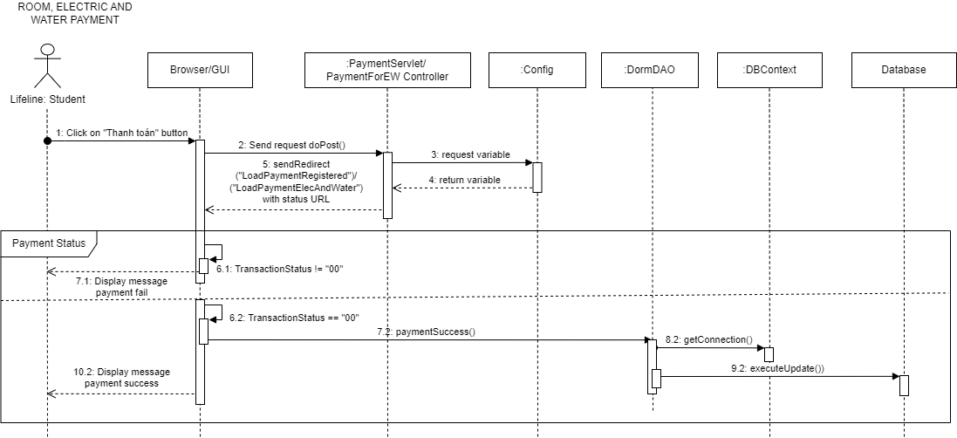

**Figure 18. Room, Electric And Water Payment Sequence Diagram**

### Request To Change Room Sequence Diagram

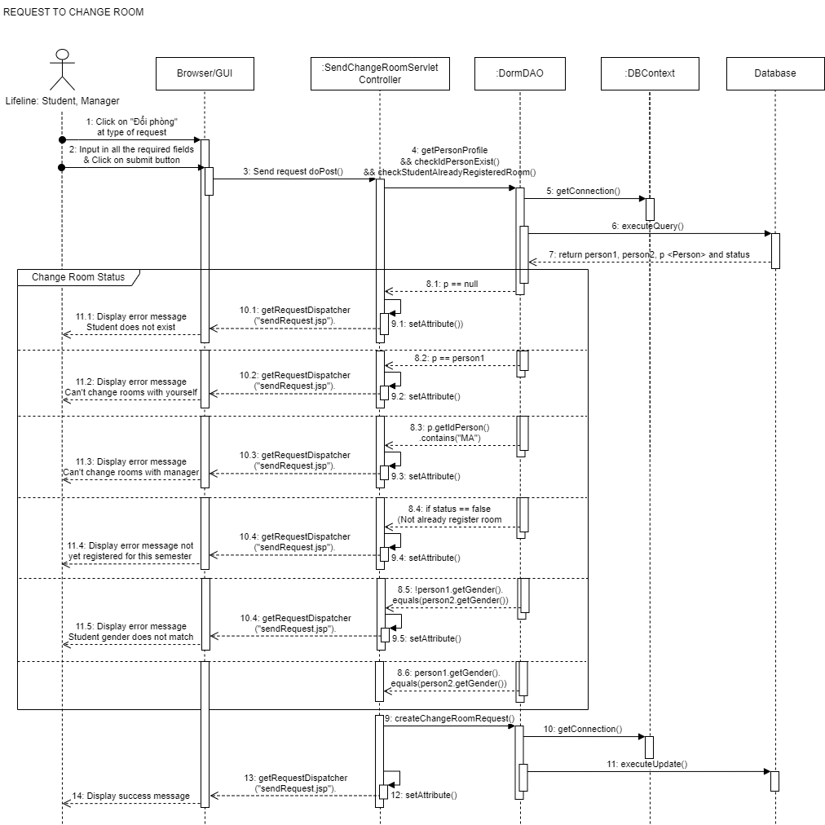

**Figure 19. Request To Change Room Sequence Diagram**

### Send Maintenance, Complain Sequence Diagram

**Figure 20. Send Maintenance, Complain Sequence Diagram**

### View All Notifications Sequence Diagram

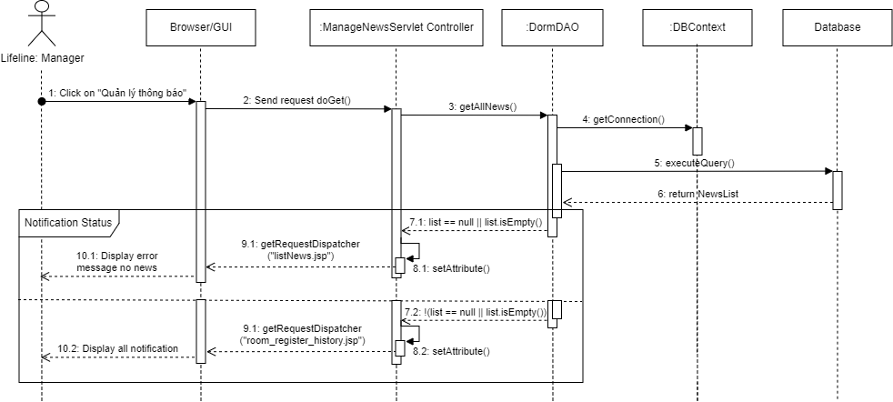

**Figure 21. View All Notifications Sequence Diagram**

### Create A Notification Sequence Diagram

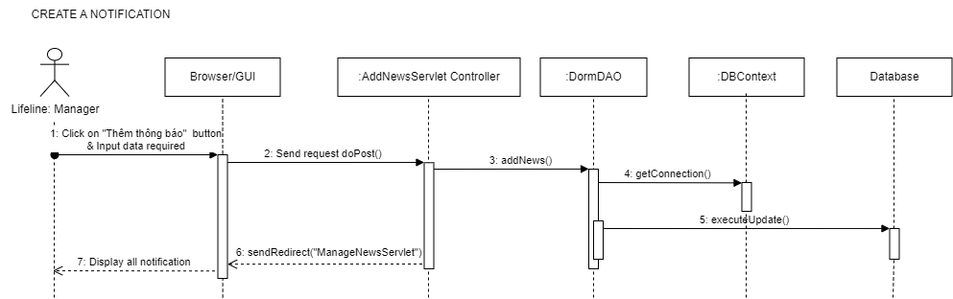

**Figure 22. Create A Notification Sequence Diagram**

### Update Notifications Sequence Diagram

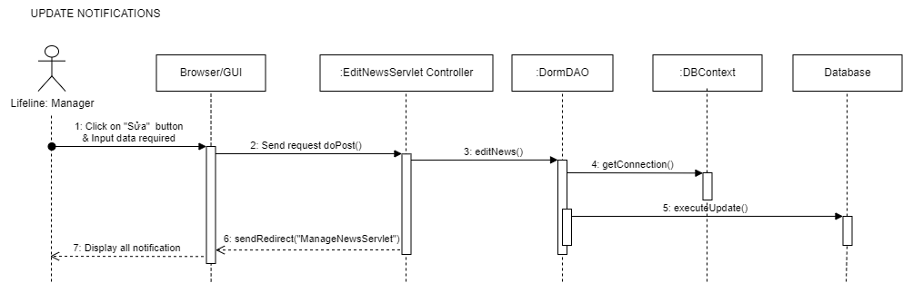

**Figure 23. Update Notifications Sequence Diagram**

### Delete Notifications Sequence Diagram

**Figure 24. Delete Notifications Sequence Diagram**

### View All Student Information Sequence Diagram

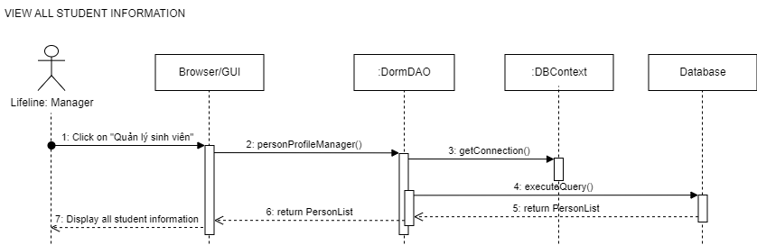

**Figure 25. View All Student Information Sequence Diagram**

### View All Room By Manager Sequence Diagram

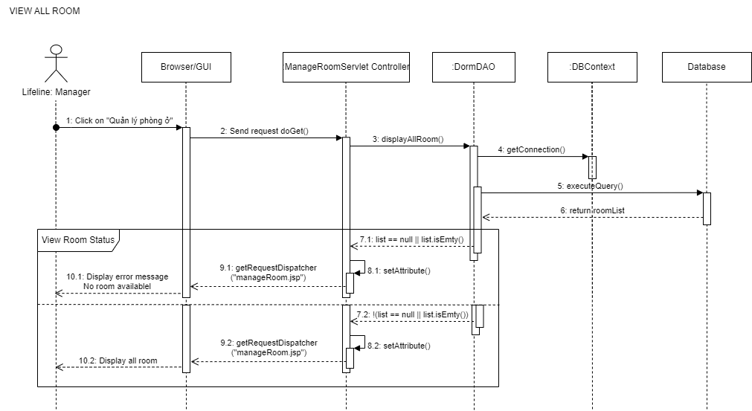

**Figure 26. View All Room By Manager Sequence Diagram**

### Create A Room Sequence Diagram

### Figure 27. Create A Room Sequence Diagram

### Update A Room Sequence Diagram

### 

### Figure 28. Update A Room Sequence Diagram

### Delete A Room Sequence Diagram

### 

### Figure 29. Delete A Room Sequence Diagram

### View All Electric And Water Bill Sequence Diagram

### 

### Figure 30. View All Electric And Water Bill Sequence Diagram

### Create An Electric And Water Bill Sequence Diagram

### Figure 31. Create An Electric And Water Bill Sequence Diagram

### Update Electric And Water Bill Sequence Diagram

### Figure 32. Update Electric And Water Bill Sequence Diagram

### Delete Electric And Water Bill Sequence Diagram

### Figure 33. Delete Electric And Water Bill Sequence Diagram

### View statistic Sequence Diagram

### 

### Figure 34. View statistic Sequence Diagram